How to install Plug in Manager and add PerfMon server Monitoring listener

**Installing Plugins**

https://jmeter-plugins.org/install/Install/

The easiest way to get the plugins is to install Plugins Manager. Then you'll be able to install any other plugins just by clicking a checkbox.

Download plugins-manager.jar and put it into lib/ext directory, then restart JMeter.

After Jmeter Restart, follow the below steps for PerfMon

**Click on Options**

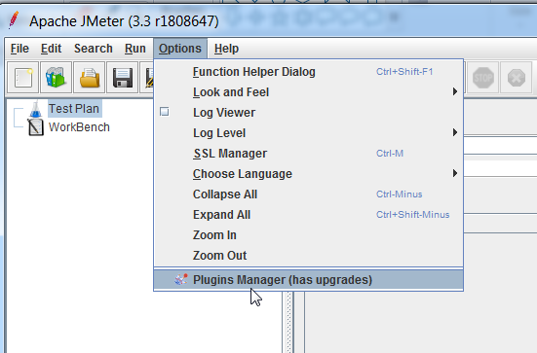

**Select PerfMon ( Server Performance Monitoring)**

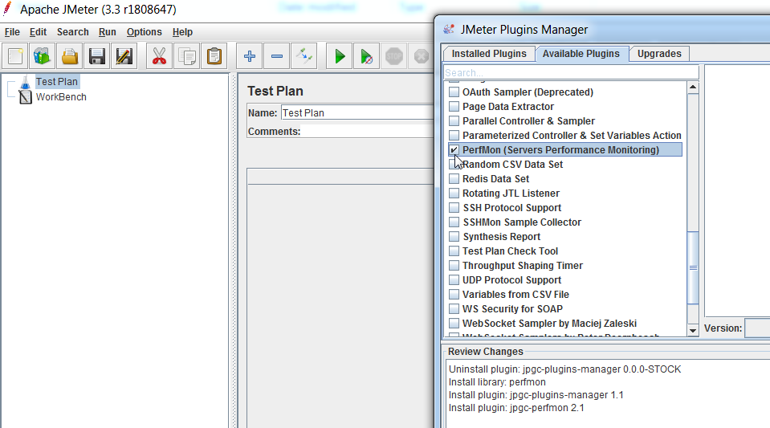

**Click on App Changes and Restart Jmeter**

